## the Magnetic Accelerator

The Magnetic Accelerator, or Gauss Gun, is a fascinating and head-scratching demonstration that is rich in physics. More importantly, it can serve as a model for biochemical reactions. In the following activity, you will investigate the unique behavior of steel balls on a track, map the progression of energy changes, and consider which interactions produce good chemical models.

Start with a simple neodymium magnet. If you roll a steel ball toward the magnet, the magnet induces a magnetic dipole within the ball. A strong force of attraction pulls the two objects together. If you roll a second steel ball toward the first ball, an attraction occurs again, but this time weaker. The third ball feels a weaker attraction still. Remove one ball at a time, noting the increasing force that you need to apply as you remove each one.

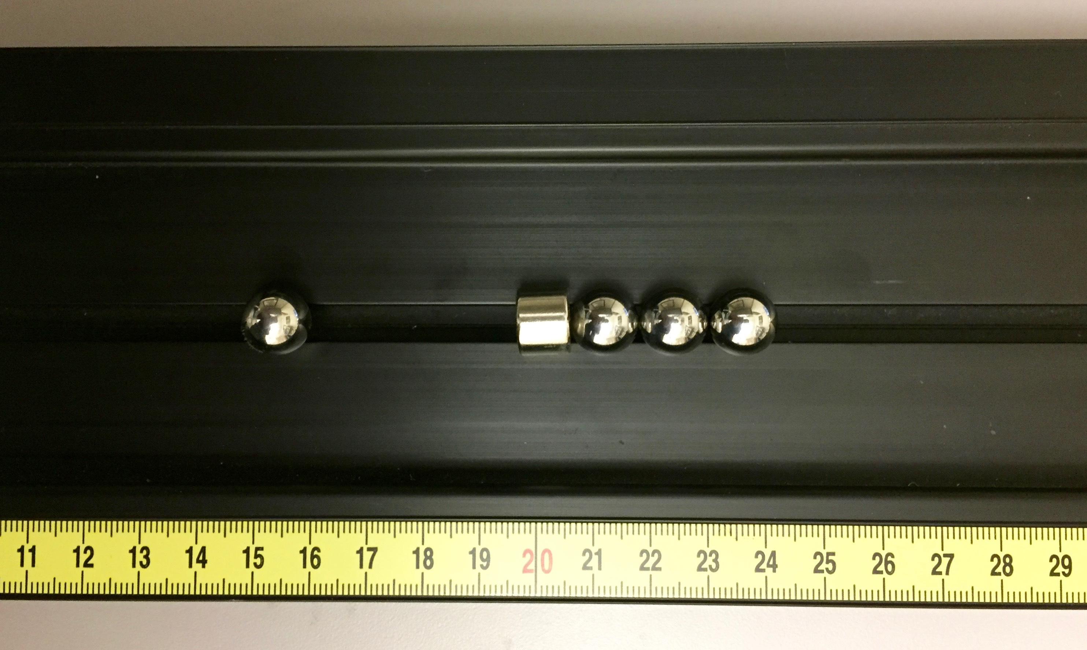Attach the three balls again and place the system in the groove of the track. Take a fourth ball and place it in the groove on the opposite side of the magnet, but do not let it get pulled in by the magnet. Your setup should look like the one pictured in Figure 1.

Figure : Basic Magnetic Accelerator setup.

Give the ball a small push, enough so that it rolls slowly toward the magnet-ball system. The incoming ball should strike the magnet and knock loose a ball on the opposite side. Repeat this scenario a few times. [Feel free to try out different scenarios – e.g. 4 balls on one side, 2 on the other, etc. – to familiarize yourself with the basic interaction.]

1. At the end of scenario, the outgoing ball has more kinetic energy than the incoming ball originally had. Based on this observation, would you say that the magnet-ball system gains or loses magnetic energy during the scenario?  Hint: Think about the conservation of energy.
2. Would you say that the initial system □ or the final system □ experiences ‘stronger bonding’? Why do you think so?  (It may be helpful to actually feel the magnet and the balls in both configurations to get a tactile sense of how tightly they are held together.)
3. Based on your previous two answers, would you say that the magnet-ball system has a higher magnetic energy when it is ‘strongly bonded’ or ‘weakly bonded’?
4. Diagram this scenario with an energy diagram (energy pies, energy bars, etc). Consider four instances: 1) the incoming ball rolling very slowly toward the magnet-ball system, 2) the moment before the incoming ball strikes the magnet, 3) the moment the outgoing ball releases from the right side, and 4) the outgoing ball farther away.
5. Based on your energy diagram above, consider question #3 again: Would you say that the magnet-ball system has a higher magnetic energy when it is ‘strongly bonded’ or ‘weakly bonded’?
6. If a magnet and ball are far apart, then no discernable attraction is felt. We say that the magnet-ball system has zero magnetic energy. When the ball and magnet come together, does the magnet-ball system have positive, zero, or negative energy? Explain your reasoning.
7. In this demonstration, it seems as though “we get something for nothing.” The incoming ball bearing is given a small push and the outgoing ball exits with a large amount of kinetic energy. To explore what is going on in more detail, take a glass marble and roll it slowly toward the initial setup. What happens? What do you need to do in order to actually remove the outgoing ball?
8. Based on the above example, which phrase is more appropriate: “breaking a bond releases energy” or “breaking a bond requires energy”?

One of the most important chemical reactions in biological systems is ATP hydrolysis. The reaction can be written as:

ATP4- + H2O 🡪 ADP3- + HPO42- + H+,

where Go = -30.5 kJ/mol. The negative Go value indicates that this reaction is exergonic. The free energy of the system is reduced, leading to an energy output (in the form of heat). The magnet-ball reaction we explored on the previous page acts as a model for ATP hydrolysis. The three balls on the right side mimic the three phosphate groups.

1. Would you expect that the molecules on the left side of this equation or the molecules on the right side of this equation are more tightly bound?  Explain.
2. When ATP hydrolyzes and “releases energy,” where does the released energy come from? Let’s take this one step at a time:
   1. “Breaking a bond requires energy.” What bonds are broken in the reaction above?
   2. Where does the energy to break the bonds come from?
   3. What new bonds form?
   4. What part of this process releases energy?
3. Based on the above questions, which phrase is more appropriate: “forming a bond releases energy” or “forming a bond requires energy”?
4. Biology books often refer to the third phosphate group as a high-energy phosphate bond, and say that when the bond breaks, energy is released. What does it mean to be a high-energy bond? Is there a better way to describe this reaction?
5. ATP hydrolysis is an example of an exothermic (and exergonic) reaction. Find a way to demonstrate an **endo**thermic reaction with the ball-and-magnet set. Sketch the setup here. How do you make this “reaction” occur? What makes this an endothermic reaction?

Endothermic (specifically, endergonic) reactions do not occur spontaneously. For instance, the first step of cellular respiration is the metabolic breakdown of glucose. This step occurs via the following phosphorylation reaction:

Glucose + HPO42- + H+ 🡪 Glucose-6-phosphate + H2O,

where Go = +13.8 kJ/mol. The positive Go value indicates that this reaction is endergonic. The free energy of the system is increased, requiring energy input if this reaction is to occur.

1. If the arrangement below represents glucose, complete the ball-and-magnet model that best represents the phosphorylation reaction described above.



1. Since this phosphorylation reaction is endergonic, it will not occur spontaneously. However, if this reaction is coupled with ATP hydrolysis, then the net Go is negative and the reaction can occur spontaneously. Couple the two ball-and-magnet models in order to induce the spontaneous phosphorylation of the glucose. Sketch the full reaction below.
2. Couple the two chemical equations and write the net chemical reaction below. Calculate the net Go as well.

*Activity written by Brad Mose r circa 2015 and shared Nov. 2021. Special thanks to the Seattle Pacific University’s Energy Project for introducing me to the activity. Many of these questions originate from or are inspired by the University of Maryland NEXUS project.